APPLICATION FORM FOR BIOMEDICAL TECHNICAL PERSONNEL

ID Picture

1. PERSONAL INFORMATION
Full Name as stated in NRIC/ Passport:

NRIC/Passport No: |  |  |  | Old/ Army/Police IC Number:
Address(Include City, State & Zip code):

Telephone No: | Mobile No: | Fax No: |  |  | Birth Date:
Email Address: |  |  |  |  | Birth Place:
Race: |  |  |  |  | Religion:
Sex: Male Female |  |  | Nationality: Malaysian Others  If others, Please specify:_____________________
Language / Dialects Spoken:
Engineering Board License Number:

Learning Objectives
Under this section you will be asked to assess your goals and capacity. Please answer all the questions completely. Please tick one (1) Competency Level which you think you are competent enough for the assessors and verifiers to assess you. Please refer to appendix A for the minimum requirements.

1.2 Competency Level being applied for:

Competency Level 1

Competency Level 2

Competency Level 3

Product Specialist (for Manufacturer)

Trainer

Management
2. ACADEMIC QUALIFICATIONS

This section will require you to provide information on your past formal, non-formal and medical device training.

CERTIFICATE/ DIPLOMA
Name of certificate/ Diploma:
Name of Institute/ College:
Years of study: | From (DD/MM/YYYY) | To (DD/MM/YYYY) | Year Award (YYYY)
DEGREE QUALIFICATION
Name of Degree:
Engineering Discipline (if related):
Format: e.g. BIOMEDICAL ENGINEERING; ELECTRICAL ENGINEERING etc.
University:
Country:
Years of Study: | From (DD/MM/YYYY) | To (DD/MM/YYYY) | Year Award (YYYY)
Mode of Study:
Format: e.g. Full Time/ Part Time/ Twinning Programme/ Distanced Learning/ Franchised Programme
OTHER DEGREE QUALIFICATION (e.g Master/ PhD)(if any)
Name of Degree:
Engineering Discipline:
Format: e.g. BIOMEDICAL ENGINEERING; ELECTRICAL ENGINEERING etc.
University:
Country:
Years of Study: | From (DD/MM/YYYY) | To (DD/MM/YYYY) | Year Award (YYYY)
Mode of Study:
Format: e.g. Research/ Coursework/ Mixed Mode
Title of Research (if any):

NOTE: All entries should be supported by Certified True Copy of Degree, Certified True Copy of Full Official Transcript or Details of Course and Subject Taken (from first year to final year) and Certified True Copy of Diploma.

2.1 Non-Formal Education

Non-formal education refers to structured and short-term training programs conducted for a particular purpose such as skills development, values orientation, and the like.

TITLE OF TRAINING PROGRAM | TRAINING PROVIDER | TITLE OF CERTIFICATE OBTAINED | INCLUSIVE DATES OF ATTENDANCE
TITLE OF TRAINING PROGRAM | TRAINING PROVIDER | TITLE OF CERTIFICATE OBTAINED | From (DD/MM/YYYY) | To  (DD/MM/YYYY)

NOTE: All entries should be supported by authenticated copy of appropriate certificates/documents obtained from the institution through the program.

2.2 Medical Device Training
Please give detailed information or certification examinations taken for vocational and other skills.
Course Attended | Name of Certifying Agency/ Training Provider | Date Certified | Inclusive Duration of Attendance
Course Attended | Name of Certifying Agency/ Training Provider | Date Certified | From (DD/MM/YYYY) | To  (DD/MM/YYYY)

NOTE: Entries should be supported by authenticated of appropriate certificates/ documents obtained from the institution through the program.

3. WORKING EXPERIENCE

3.1 Position/ Designation Title |  | 3.2 Name & Address of Company | 3.3 Inclusive Dates of Employment
 |  | 3.2 Name & Address of Company | From (DD/MM/YYYY) | To  (DD/MM/YYYY)
Work 1:
Work 2:
Work 3:
3.4 Terms/ Status of Employment (Part Time/ Full Time)
Work 1:
Work 2:
Work 3:
3.5 Name and Designation of Immediate Supervisor:
Work 1:
Work 2:
Work 3:
3.6Describe actual function and responsibilities in the position occupied:

Work 1:
Work 2:
Work 3:
3.7 In case of self-employment, name two (2) reference persons:

NOTE: Entries should be supported by authenticated of appropriate certificates/cover letter/ supporting documents obtained from your supervisor (s).

4. HONORS, AWARDS AND CITATIONS RECEIVED
In this section, please describe all the awards you have receive from organizations as well as citations for work excellence, outstanding accomplishments, professional bodies, etc

Work-Related Award / Citation
Award Conferred | Name and Address of Conferring Organization | Date Awarded

6. DECLARATION
I am fully responsible with all the information provided in this declaration. This application form for technical personnel is valid from ………………..(Day) …………………………(Month) …………………… (Year).
I fully understand and acknowledge that it is an offence under Section 76 of the Medical device Act 2012 [Act 737] to make, sign or furnish any declaration, certificate or other document which is untrue, inaccurate or misleading.

(Signature of Applicant)
Name of Applicant: Date:

Verified by:

(Signature of Immediate Superior)
Name of Supervisor: Date:

Medical Device Authority will ensure that all information held about will be dealt with confidentiality held securely and only processed in accordance with Data Protection Policy.

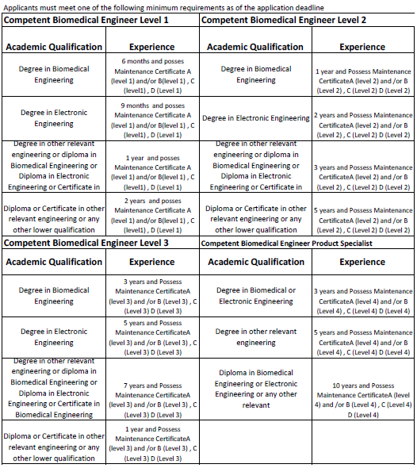
APPENDIX A

