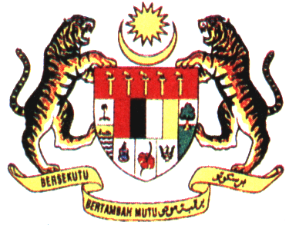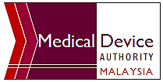
MEDICAL DEVICE AUTHORITY
MINISTRY OF HEALTH
TRAINING BY THE AUTHORITY: -
MEDIGAS GAS SYSTEM TRAINING: REGISTRATION REQUIREMENTS
18TH SEPTEMBER 2020,
MEDICAL DEVICE AUTHORITY
REGISTRATION FORM

*Title | Dato’ / Datuk / Datin / Prof. / Assoc. Prof / Dr. / Ir. / Mr. / Mrs. / Puan / Ms.
Full Name
Name on ID Card |  | *IC / Passport No.
Organization Name & Address | 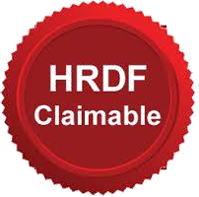
Telephone No. |  | Facsimile No.
Mobile No. |  | E-mail Address
Training Fee | RM 700.00 / participant
Payment Mode | More details on Payment Method will be sent to participants upon  confirmation of registration

Please submit the registration form (.pdf format) to trainingpackage@mda.gov.my
For more information, please contact Mr Talha at 603 8230 0383 / Mr Luqman at 603 8230 0212

