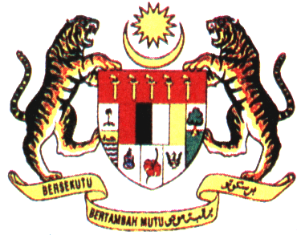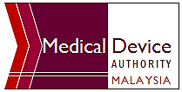
MEDICAL DEVICE AUTHORITY
MINISTRY OF HEALTH
TRAINING BY THE AUTHORITY: - COMPULSORY COMPETENCY MODULE (REGULATORY REQUIREMENTS) FOR BIOMEDICAL TECHNICAL PERSONNEL
12TH (Training) & 13TH (Examination) FEBRUARY 2020,
MEDICAL DEVICE AUTHORITY
REGISTRATION FORM
*Title | Dato’ / Datuk / Datin / Prof. / Assoc. Prof / Dr. / Ir. / Mr. / Mrs. / Puan / Ms.
Full Name
Name on ID Card |  | *IC / Passport No.
Organization Name & Address | 
Telephone No. |  | Facsimile No.
Handphone No. |  | E-mail Address
*Vegetarian? | Yes / No | *Required Invoice? | Yes / No
Training Fee | RM 750.00 / participant  - Inclusive of refreshments, lunch (12 February 2020), training materials, examination & certificate.  - No meal will be provided on the examination day (13 February 2020).  - Training fee does not include accommodation & travelling costs.  - Confirmation of registration will be valid upon the receipt of the Registration Form & enclosed with the copy of the bank draft.  - Please submit the registration form and copy of bank draft (.pdf format) to trainingpackage@mda.gov.my
Payment Mode | The training fee shall be made through Bank Draft / Local Order and payable to “KUMPULAN WANG PIHAK BERKUASA PERANTI PERUBATAN”  - Payment receipt will be issued upon the receipt of the original bank draft during the registration day.
Payment Mode | *Bank Draft / Local Order No. |  | Amount | RM 750.00
Payment Mode | Bank Name
For more information, please contact Ms.Shamala at 603 8230 0223

