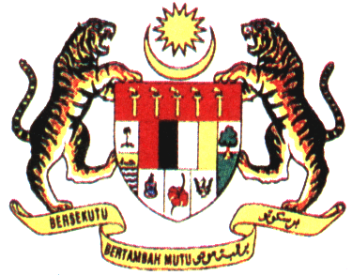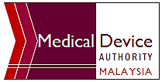
PIHAK BERKUASA PERANTI PERUBATAN
MEDICAL DEVICE AUTHORITY
MINISTRY OF HEALTH
Email: trainingpackage@mda.gov.my
TRAINING BY THE AUTHORITY: - NOTIFICATION OF EXPORT ONLY MEDICAL DEVICE AND REQUIREMENT FOR APPLICATION OF CERTIFICATE OF FREE SALE (CFS) FOR EXPORT ONLY MEDICAL DEVICES
19TH AUGUST 2019, MEDICAL DEVICE AUTHORITY
Registration Form
Name
NRIC/ Passport
Organization Name
Company Address
Postcode |  | State
Telephone no. |  | Email
Hand phone no. |  | Fax no.
Vegetarian | YES / NO | Invoice | YES / NO
Venue | BILIK SEMINAR 1 & 2, LEVEL G, PRIMA 9, 63000 CYBERJAYA
Registration Fees | RM 350.00
Mode of Payment | Bank draft  No:_________________ for the sum of RM_______________  *Payment should be made to “KUMPULAN WANG PIHAK BERKUASA PERANTI PERUBATAN”.  *Payment in Malaysia Ringgit (MYR only).  *Please bring the BANK DRAFT on the day of registration.  *Participant’s name on the CERTIFICATE will be based on name  given on the registration form.
E-mail completed form to trainingpackage@mda.gov.my . For more information, please contact Mohd Shahrezza Bin Sirun at 603 8230 0392
= Only completed form with the bank draft will be accepted during the registration =
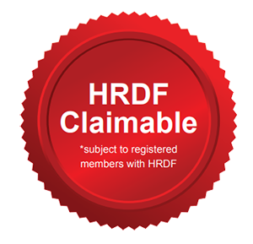
Administrative use only
Received date:

